Marking scheme sample question paper 1- IX
q. no. | Answer | Marks
1 | Any substance is said to be pure if and only if it is made up of a single type of particles | 1
2 | True Solution , Suspension , Colloid.  OR  Distillation | 1
3 | Negative charge | 1
4 | hydrogen (H₂), nitrogen (N₂), oxygen (O₂), fluorine (F₂), and chlorine (Cl₂).(any one )  OR  7 atoms | 1
5 | Adenosine triphosphate. ATP is the energy currency of the cell | 1
6 | (c) Leucoplasts | 1
7 | plastids and mitochondria | 1
8 | A group of cells that perform similar functions & have similar structure is called Tissue.  OR  Transportation of water and minerals | 1
9 | - Fever.Diarrhoea.Fatigue.Muscle aches.Coughing (any two) | 1
10 | - Immunity is the ability of the body to defend against a disease.  - OR  - Female Anopheles mosquito. | 1
11 | - Newton’s second law of motion. | 1
12 | The force acting between any two surfaces in contact and tending to oppose motion is called force of friction.  OR  1 newton is the magnitude of force which produces an acceleration of 1 m/s2 in a body of mass 1 kg. | 1
13 | No kinetic energy doesn't depend on the direction of motion. Kinetic energy=1/2mv2. It depends on the mass and velocity of object | 1
14 | - Both A and R are true, and R is correct explanation of the assertion  OR  (b) Both A and R are true, but R is not the correct explanation of the assertion. | 1
15 | (b) Both A and R are true, but R is not the correct explanation of the assertion. | 1
16 | (a) Both A and R are true, and R is correct explanation of the assertion. | 1
17.1 | - Amount of Substance | 4 x 1
17.2 | © 6.022 X 10²³ in number | 4 x 1
17.3 | (d) 12 gram | 4 x 1
17.4 | (b) 3 moles | 4 x 1
17.5 | 12.022 x 10²³ | 4 x 1
18.1 | (c) PLATELETS | 4 X 1
18.2 | (b) plasma | 4 X 1
18.3 | (a) Loss of Blood | 4 X 1
18.4 | (d) Red Blood cells | 4 X 1
18.5 | If there are no platelets, the blood would not clot in case of an injury. This will lead to excess blood loss and can even lead to the death of a person. | 4 X 1
19.1 | (b) anticlockwise | 4 X 1
19.2 | (a) TWO ROTATION | 4 X 1
19.3 | (c) A-SIX, B-TWO | 4 X 1
19.4 | (d) circular motion | 4 X 1
19.5 | 1:1:1 | 4 X 1
20.1 | - His body weight is higher in poles than the equator | 4 X 1
20.2 | (b) weight | 4 X 1
20.3 | (a) Increase | 4 X 1
20.4 | (b) Newton | 4 X 1
20.5 | Centre of the earth | 4 X 1
21 | 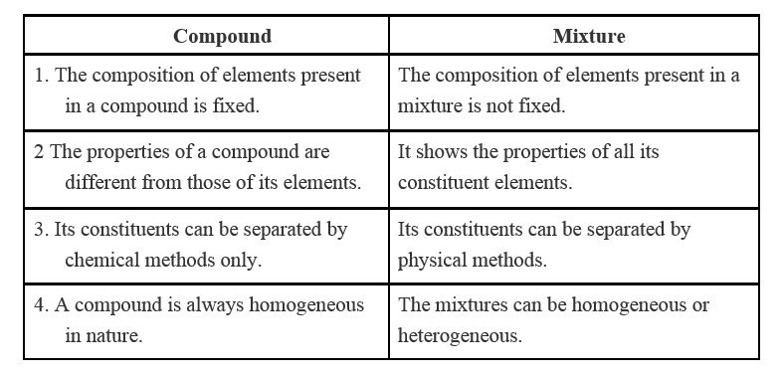any two difference  OR  1. water is made up of two elements in a fixed ratio  2. water has totally different properties from the two elements  3. its constituents can be separated only by chemical or electrochemical reactions  4. water is formed by reaction between hydrogen and oxygen. | 2
22 | Molar mass of hydrogen peroxide (H₂O₂) = 2(mass of hydrogen) + 2(mass of oxygen) = 2 x 1 + 2 x 16= 34g.  Molar mass of Nitric Acid (HNO3) = mass of hydrogen + mass of nitrogen + 3(mass of oxygen)= 1 + 14 + 3 x 16 = 63g. | 2
23 | Isotonic solution: A solution that has the same water concentration as cells and solution | 2
24 | Diseases that are easily transmitted from one person to another are known as infectious diseases, They are caused by infectious microorganisms like viruses, bacteria, helminths,  whereas diseases that remain confined to a person are known as non-infectious diseases  OR  because if we will stop the basic growth of disease then we will not suffer from that | 2
25 | According to Newton’s third law of motion, action and reaction are equal and opposite. It means that the force on the apple due to earth’s attraction is equal to that on the earth due to apple’s attraction. As the mass of the earth is very large as compared to that of the apple, the acceleration experienced by the earth will be so small that it will not be noticeable. | 2
26 | Antibiotic is a chemical substance secreted by microorganisms which can kill the pathogens. Example : Penicillin. | 2
27 | Chromatography is a technique used for the separation of a mixture of solutes brought about by distribution of dissolved material between two immiscible phases, one of which is mobile phase and the other part is stationary phase. It is useful in forensic science to detect and identify trace amounts of substances in the contents of bladder or stomach | 3
28 | All matter consists of indivisible particles called atoms. Atoms of the same element are similar in shape and mass, Atoms cannot be created or destroyed. Atoms of different elements may combine with each other in a fixed, simple, whole number ratios to form compound atoms. | 3
29 | The number of electrons gained, lost or shared to make the octet of electrons (in the outermost shell), gives us directly the combining capacity of the element, that is, the valency.  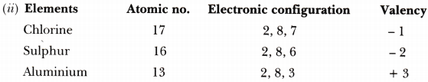 | 3
30 | 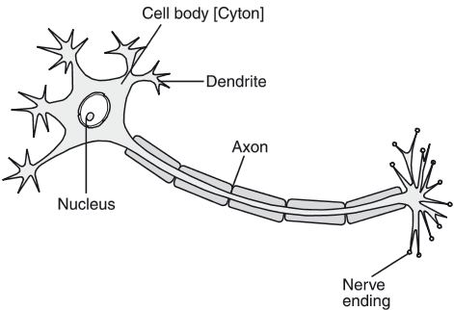  OR  Cardiac muscles is an involuntary, striated muscle that is found in the walls and histological foundation of the heart, specifically the myocardium, pumps blood through arteries without rest | 3
31 | Vaccines consist of dead or weak germs which enter the body and stimulate the production of anti bodies which stay in the body for a long period of time and keep protecting the body from further attacks by the same microorganisms | 3
32 | v = u + at  At, its highest point velocity v = 0; also during upward journey a = -g;  0 = 49 - 9.8 X t  t = 5 sec.  = 2as ;  0 - = -2 x 9.8 x h(S)  Maximum height h(s) = 122.5m | 3
33 | Work: It is defined as the product of force applied and the distance moved by the body on the application of the force. In SI it is measured in joule.  Energy : It is defined as the capacity of a body to do work. In SI it is measured in joule.  Power: It is defined as the rate of doing work. It measures how fast or slow the work is done. In SI it is measured in watt. | 3
34 | *Only certain special orbits known as discrete orbits of electrons, are allowed inside the atoms.  *While revolving in discrete orbits the electrons do not radiate energy. These orbits are called energy levels.  *Energy levels in an atom are shown by circles.  *These orbits are represented by the letters K, L, M, N, … or the numbers n = 1, 2, 3, 4, …  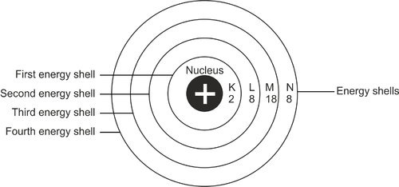  OR  Since the atomic number of sodium atom is 11, it has 11 electrons. A positively charged sodium ion (Na⁺) is formed by the removal of one electron from a sodium atom. So, a sodium ion has 11 – 1= 10 electrons in it. Thus, electron distribution of sodium ion will be 2, 8. The atomic number of an element is equal to the number of protons in its atom. Since, sodium atom and sodium ion contain the same number of protons, therefore, the atomic number of both is 11.  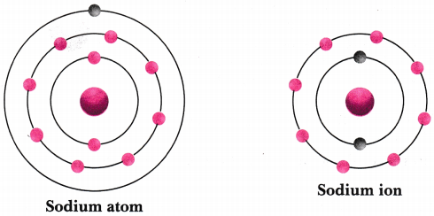 | 5
35 | - Any three  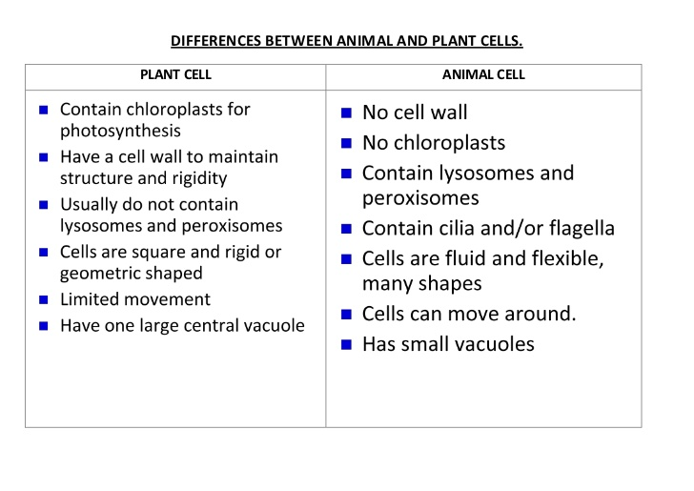  - Mitochondria are known as the power houses of the cell. They produce Adenosine Triphosphate (ATP). They are required for cellular respiration. It has its own DNA and ribosome’s | 3+2
36 | Consider an object of mass m moving along a straight line with an initial velocity u (say). It is uniformly accelerated to velocity u in time t by the application of a constant force F in time t.  Then, initial momentum of the object = mu  p₁ =mu  Final momentum of the object = mv  p₂ = mv  ∴ Change in momentum = mv – mu = m(v – u)  The rate of change in momentum = m×(v−u)/t  According to Newton’s second law of motion, we have  F ∝ m(v−u)/t  F = km(v−u)/t  F = kma ……….(1)  Here, a = v−ut = the rate of change of velocity.  = acceleration  k = a constant of proportionality  Putting m = 1kg, a = 1 ms⁻²  F becomes 1 N.  So, 1 N = 4 × 1kg × 1 ms⁻²  ∴ k = 1  From equation (1), we have  F = ma  This represents the second law of motion.  Thus, the second law of motion gives a method to measure the force acting on an object as a product of its mass and acceleration.  OR  - In this problem, force, F = 12 N  Mass, m = 3 kg  We know that F = m × a,  Putting the given values, we have  12 = 3 × a  a = 12/3 m/ s²  or, Acceleration, a = 4 m/s².  - initial velocity of sphere, u = 0  Distance travelled, s = 10 m  Acceleration of sphere, a = 9.8 ms⁻²  Final velocity of sphere when it just reaches the ground can be calculated using  v² – u² = 2as  or, v² – 0 = 2 × 9·8 ms⁻² × 10 m = 196 m²s⁻²  or, v = √196 m²s⁻² = 14 ms⁻¹  Momentum of the sphere just before it touches the ground = mv  = 1 kg × 14 ms^{– 1} = 14 kg ms⁻¹  On reaching the ground, the iron sphere comes to rest, so its final momentum is equal to zero according to the law of conservation of momentum.  Momentum transferred to the ground = Momentum of the sphere just before it comes to rest = 14 kg ms⁻¹ | 5

